Andrew Fagundes
Department of Information Technology, Western Governors University
D209 Data Mining: Task 2
Professor Eric Straw
November 14th, 2024

Table of Contents
Part I: Research Question and Variables 4
A1: Research Question (Decision Trees) 4
A2: Goal of the Data Analysis 4
Part II: Method Justification 5
B1: Explanation of Classification Method 5
B2: Summary of One Assumption of the Chosen Classification Method 6
B3: Packages or Libraries Used in Python and How They Support the Analysis 7
Part III: Data Preparation 7
C1: One Data Preprocessing Goal Relevant to Decision Trees 7
C2: Initial Data Set Variables for Analysis and Classify Each Variable as Numeric or Categorical 9
C3: Explain Each Step to Prepare Data for Analysis – Identify Code for Each Step 9
C4: Provide Copy of Cleaned Data Set (this is in assessment submission) 16
Part IV: Model Analysis 16
D1: Split Data into Training and Test Data Sets and Provide File(s) (this is in assessment submission) 16
D2: Describe Analysis Technique to Analyze Data – Include screenshots of intermediate calculations 16
D3: Provide code used to perform classification analysis from part D2 18
Part V: Data Summary and Implications 21
E1: Explain Accuracy and Mean Squared Error (MSE) of Classification Model 21
E2: Discuss Results and Implications of Decision Trees 22
E3: Discuss one limitation of your data analysis 22
E4: Recommend a course of action for the real-world organization situation from part A1 based on your results and implications discussed in part E2 23
References (No third-party code references used) 24
Table of Figures 25

Part I: Research Question and Variables

A1: Research Question (Decision Trees – May need to change for continuous outcome variable?)
For the medical data set, the research question is the following: “Can we predict whether a patient is hypertensive by using the decision trees methods based on the available data?” This question can help a hospital determine what factors can estimate a patient’s high blood pressure. This question was also chosen to follow up with the research I did in D209 Task 1, where the KNN analysis was used. In that assessment, the accuracy scores were 59% for the training and testing models, which means they were not great in classifying high blood pressure in patients. Decision trees are being used to see if the efficiency and effectiveness of the models can be improved. The dependent variable, HighBlood, will work for this question since it is a categorical variable, which works for decision trees.

A2: Goal of the Data Analysis
The goal of using decision trees is to test which variables are most closely related to patients having high blood pressure (“HighBlood”). Decision trees will be used to help predict a patient’s hypertension status based on patient-specific variables contained in the dataset. By determining what factors influence whether a patient is hypertensive or not, it could help the hospital prevent readmission due to this issue.

Part II: Method Justification

B1: Explanation of Classification Method
A decision tree is a machine learning algorithm that can handle both categorical and numerical data, requires less computation time and training time, is not sensitive to the outlier, and is nonparametric (Elleh 2024). Thus, the decision tree is a good fit for the data set.
The decision tree has five nodes, including three leaf nodes (Elleh 2024). According to Sehra (2020), a decision tree breaks down the data set into smaller subsets of instances with similar values (homogenous) like a flowchart diagram. Each subset has a leaf node and a decision node. Each node represents features, and each branch represents a decision rule (test outcome) (Elleh 2024). There are two or three branches or sub-trees on a decision node (Elleh 2024). A terminal leaf node is the end of the algorithm, representing a final decision (outcome) (Elleh 2024). The topmost decision node is the root node, meaning the best predictor (Elleh 2024). The root nodes would be based on the features selection completed during SelectKBest. These will be the best predictors based on their p-values. Decisions are made upon these nodes based on Yes/No, or a numerical comparison, which find its way down the branches towards the terminal leaf node. For this assessment, the terminal node will contain the answer to the question, in this case whether the patient has high blood pressure or not.
There are several positive reasons for using decision trees. Decision trees are easy to interpret and visualize (Elleh 2024). It can easily capture non-linear patterns (Elleh 2024). It requires fewer data preprocessing from the user, for example, there is no need to normalize columns (Elleh 2024). It can be used for feature engineering such as predicting missing values, suitable for variable selection (Elleh 2024). The decision tree has no assumptions about distribution because of the non-parametric nature of the algorithm (Elleh 2024)
There are several negative reasons for using decision trees. It is sensitive to noisy data. It can overfit noisy data (Elleh 2024). The small variation (or variance) in data can result in the different decision tree. This can be reduced by bagging and boosting algorithms (Elleh 2024). Decision trees are biased with imbalanced data set, so it is recommended to balance out the data set before creating the decision tree (Elleh 2024).
There are multiple expected outcomes when using decision trees. A decision tree can help you analyze each option’s risks, benefits, and costs and compare them visually (Elleh 2024). Each leaf node contains a predicted value, typically the mean of the target values of the training instances in that leaf (Elleh 2024). Decision trees can estimate variance or error by analyzing the spread of target values within leaf nodes (Elleh 2024). Regression trees provide insights into the importance of features in making predictions, based on how frequently they are used in splits and how well they reduce variance in the target values (Elleh 2024). Decision trees offer a clear and interpretable model where you can visually follow the path of decisions from the root to a leaf to understand how predictions are made (Elleh 2024). They handle non-linear relationships between features and the target variable effectively, as they partition the feature space into distinct regions (Elleh 2024). Decision trees provide a set of decision rules that can be easily interpreted and translated into a series of “if-then” statements, useful for decision making processes (Elleh 2024).

B2: Summary of One Assumption of the Chosen Classification Method
According to Navlani (2018), one assumption of the decision tree algorithm is that it is non-parametric (Elleh 2024). It doesn’t make distribution assumptions on the data (Elleh 2024). Thus, decisions can efficiently deal with non-linear, skewed, multi-modal, categorical, ordinal, and non-ordinal data (Elleh 2024). This characteristic makes the model easier to understand, interpret, and visualize (Elleh 2024).
One assumption that must be satisfied for the decision tree to be valid is that there are no missing values in the dataset or that these values have been appropriately handled through imputation or other methods (Elleh 2024).

B3: Packages or Libraries Used in Python and How They Support the Analysis
The libraries used in the analysis were the following: Pandas was used as the main data manipulation tool, Seaborn and Matplotlib were used to visualize the data, Numpy was used as numerical computation tool, and SKLearn was used to pre-process the data for the algorithm. Train_test_split is used to split the cleaned data into training and testing data sets. SelectKBest is used for feature selection. DecisionTreeClassifier is used to fit several decision trees. GridSearchCV performs exhaustive search over the specified parameter values for an estimator. AdaBoostClassifier is used to tune the decision tree model. Make_scorer is the scoring function to use in GridSearchCV. Mean_squared_error is used to get the mean squared error metric score for the model. R2_score is used for getting the R2, the coefficient of determination. Mean_absolute_error is for getting the mean absolute error score.

Part III: Data Preparation

C1: One Data Preprocessing Goal Relevant to Decision Trees
One important step was to re-express the categorical explanatory variables. The data transformation that was required was limited to the re-expression of categorical variables to numerical variables. The reason the categorical variables are re-expressed is because most statistical methods and machine learning algorithms mining work exclusively with numeric data. This means that categorical data must be encoded to numbers to perform statistical modeling. For binary categorical columns, “Yes” will change to 1 and “No” to 0. For categorical variables with more than 2 levels or categories, you can use one-hot or dummy encoding. For the binary columns, drop_First=True is used to include only one column per category, reducing redundancy and improving the model’s simplicity and efficiency (Elleh 2024). For categorical variables with three or more catgeories, drop_First=False is used to ensure the model does not lose any important information from these features (Elleh 2024). This means that a categorical variable with more than two categories or classes should not drop any categories (Elleh 2024). Categorical data, sometimes called qualitative data, are data whose values describe some characteristic or category. There are two types of categorical data, namely: ordinal, which is in an inherent order, and nominal, which are names only that are in no inherent order. One approach is to find and replace the dictionary created for cleaning up specific columns (Ex. Name of dataframe = dataframe.replace(name of dictionary)). Another approach is to encode categorical values is to use a technique called label encoding (https://pbpython.com/categorical-encoding.html). Label encoding is simply converting each value in a column to a number (https://pbpython.com/categorical-encoding.html). Some binary variables can be arranged as ordinal categorical variables such as Yes/No or True/False. A method to use for this is Ordinal Encoder Technique, which is done on Python through the OrdinalEncoder.fit_transform function (Straw 2024). For nominal data, one-hot encoding is the most widespread approach, and it works very well unless your categorical variable takes on many values. For one hot encoding, this has the benefit of not weighting a value improperly but does have the downside of adding more columns to the data set. For this step, the Pandas functionality, .map() was used for the binary nominal variables such as HighBlood, Stroke, Overweight, Arthritis, Diabetes, Hyperlipidemia, BackPain, Anxiety, Allergic_rhinitis, Reflux_esophagitis, and Asthma. The .map() function maps “Yes/No” to 1 and 0. For the nominal columns with multiple categories such as Gender, Area, Initial_admin, Marital, and Services, .get_dummies is used for one-hot encoding. Drop_first in the function is defined as “False” since it is advisable to retain the dummies (Bruce 2020). The OrdinalEncoder functionality from SKLearn was used for the only ordinal variable used in the model, Complication_risk.

C2: Initial Data Set Variables for Analysis and Classify Each Variable as Numeric or Categorical
Based on SelectKBest, the predictor variables with significant p-values (p < 0.05) were Overweight and Marital_Married. These variables are categorical. The response variable is HighBlood and is also categorical. SelectKBest is used to select the correct variables and eliminate those that do not help much with the prediction, thus improving a predictive model’s efficiency and effectiveness (Elleh 2024).

C3: Explain Each Step to Prepare Data for Analysis – Identify Code for Each Step
To being the assessment, we must import the proper libraries and packages to use for coding in Python. Then, we must load the clean medical dataset. This is done through pd.read_csv(‘medical_clean.csv”, index_col=0).
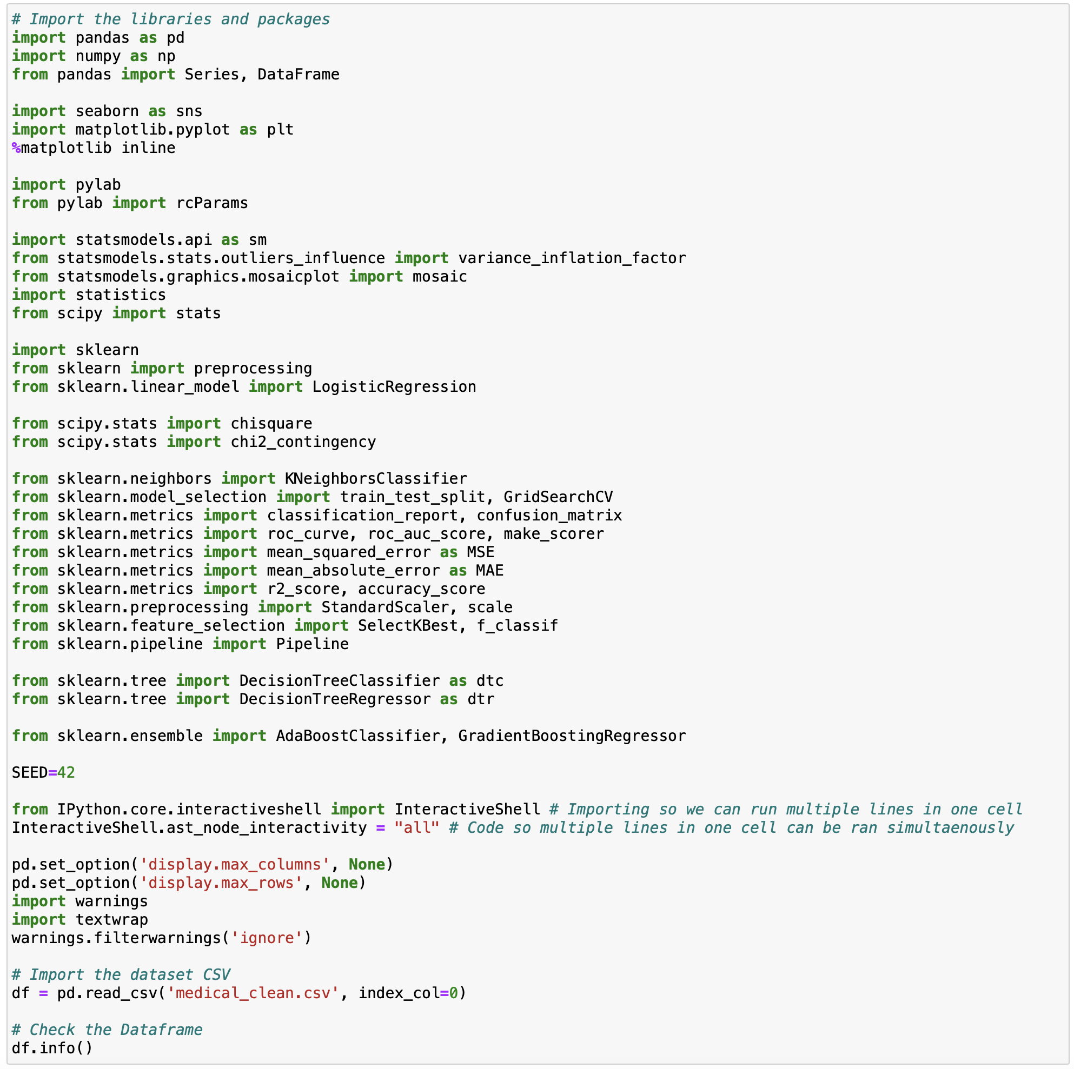
Figure 1: Importing Libraries and Loading Data
Before beginning the decision tree analysis, it is crucial that we have cleaned and prepared the data for analysis. To do so, we will detect and treat duplicates, missing values, and outliers, as well as make necessary changes as appropriate such as re-expression of categorical variables into numerical variables and ensuring that the columns of the data frame are stored as the correct data type. First, we rename the columns to give proper naming to predictors. 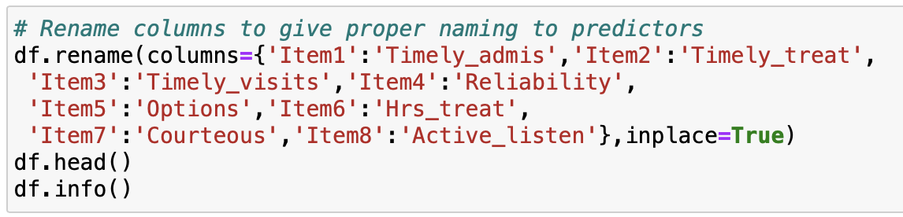
Figure 2: Renaming Columns
To detect missing values, we will use df.isna().any() and df.isnull().sum(). If there are none, then the output should be False and 0. To detect duplicates, we will use df.duplicated().value_counts() to determine if any duplicates exist in the data frame. Next, we will find the count of unique values in each column with df.nunique() followed by using df[‘variableofinterest’].value_counts to find unique values for the independent and dependent variables (https://datascienceparichay.com/article/pandas-count-of-unique-values-in-each-column/, Piyush Raj 2024). Df.nunique() can also be used to determine the levels of cardinality of each variable. Demographic data and irrelevant variables with more than three levels of cardinality will be removed since they are not relevant to the research question. This is done with the following code: df = df.drop(['Customer_id','Interaction', 'UID', 'City', 'State', 'County', 'Zip', 'Lat', 'Lng', 'Population', 'TimeZone', 'Job', 'Children','ReAdmis', 'Full_meals_eaten','vitD_supp', 'Soft_drink', 'Additional_charges', 'Timely_admis', 'Timely_treat', 'Timely_visits', 'Reliability', 'Options', 'Hrs_treat', 'Courteous', 'Active_listen'], axis=1, inplace=True). If any duplicate data entries, rows, or columns are found, they will be removed.
Feature selection is important to understand which features are useful in predicting a target variable. This helps select the correct features and eliminate those that do not help much with the prediction, thus improving a predictive model’s efficiency and effectiveness. This is accomplished with SelectKBest. SelectKBest selects features that have a p-value of .05 or less to be used in the final model.
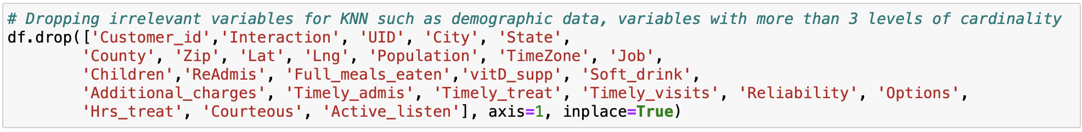
Figure 3: Dropping Irrelevant Variables
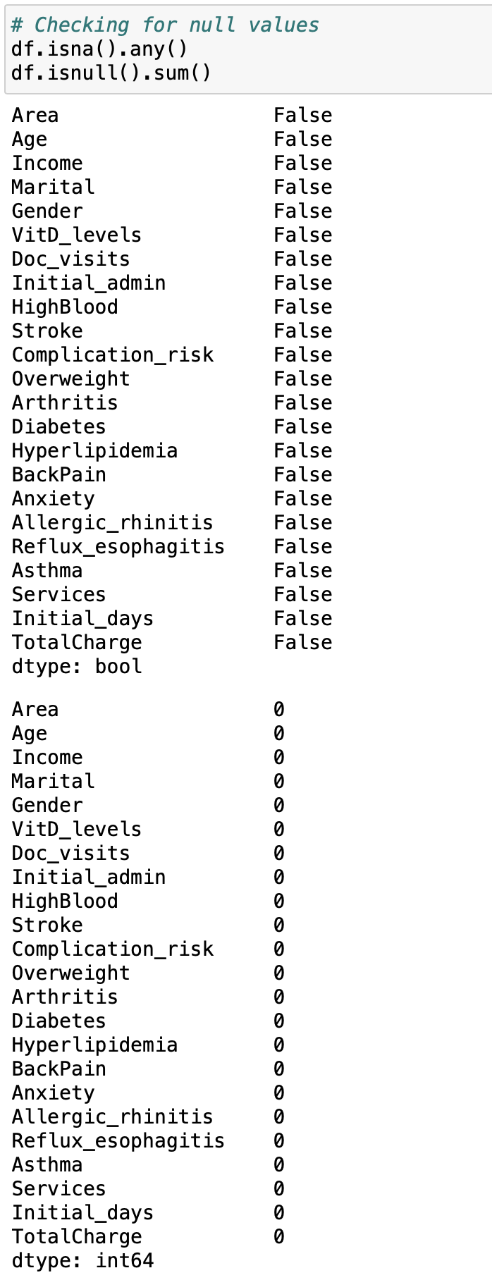
Figure 4: Checking for Null Values
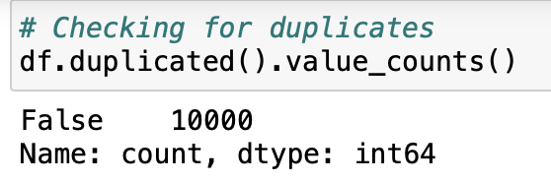
Figure 5: Checking for Duplicates
The final data pre-processing step is re-expressing categorical variables. To convert the binary categorical columns, we used .map({‘Yes’: 1, ‘No’: 0}) to map ‘Yes/No’ to 1 and 0.
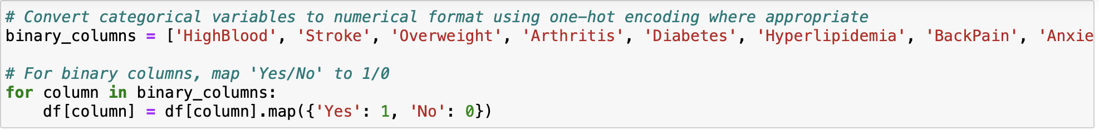
Figure 6: Mapping Binary Categoricals
The .get_dummies() functionality from Pandas was used to convert the nominal variables with multiple categories such as Area, Marital, Gender, Initial_admin, Services. Drop_first is equal to false because we want to keep the dummies. For categorical variables with three or more catgeories, drop_First=False is used to ensure the model does not lose any important information from these features (Elleh 2024). This means that a categorical variable with more than two categories or classes should not drop any categories (Elleh 2024).
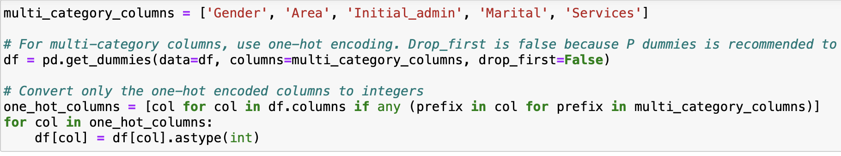
Figure 7: Get_dummies to Re-express Categorical Variables
The only ordinal variable was Complication_risk and for this OrdinalEncoder from SKLearn was used – Low, Medium and High were converted to 0, 1, 2 respectively.
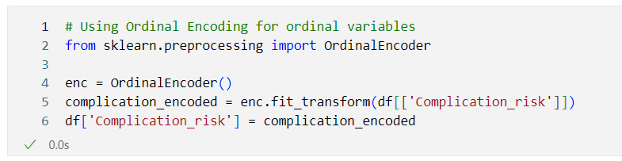
Figure 8: Ordinal Encoding for Complication_risk
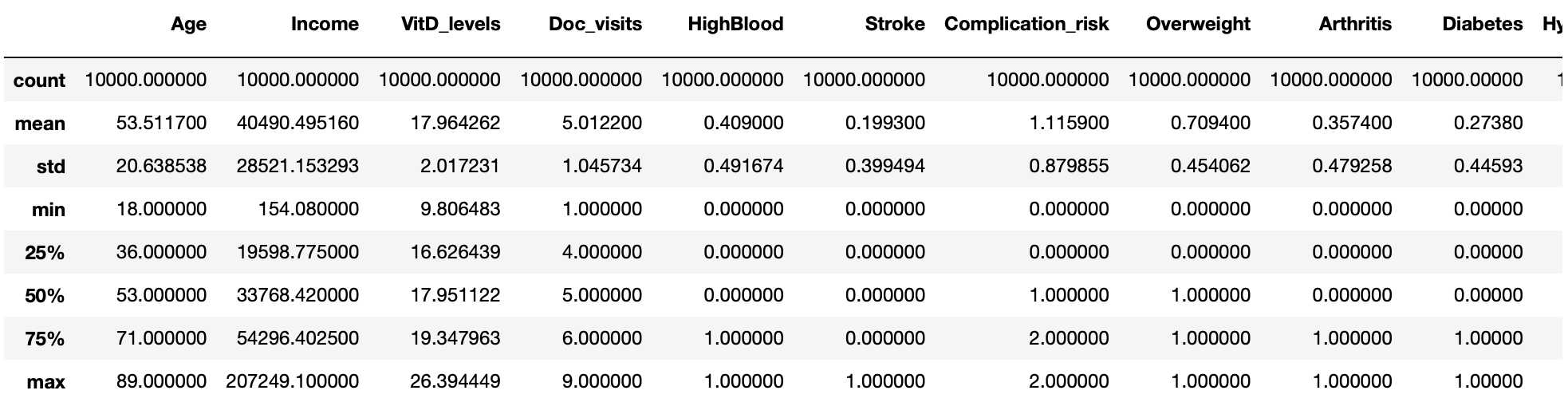
Figure 9: Summary Stats of Cleaned Data Frame
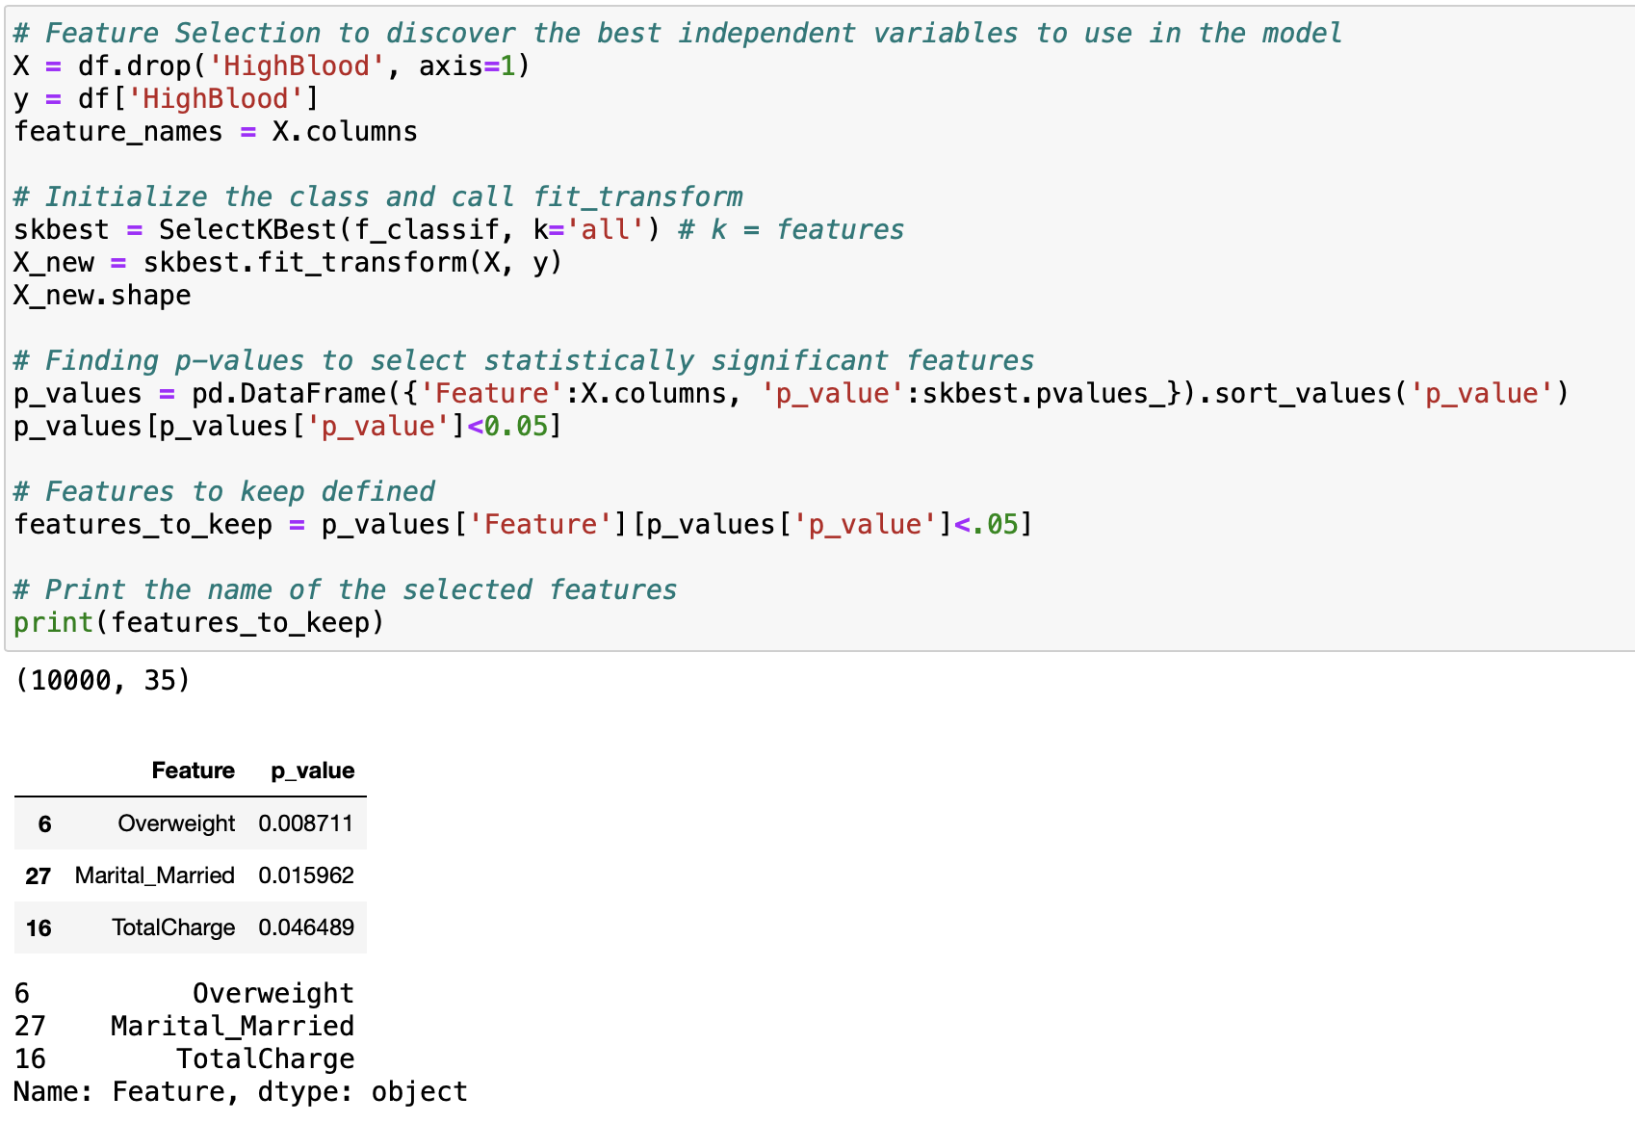
Figure 10: Feature Selection with SelectKBest
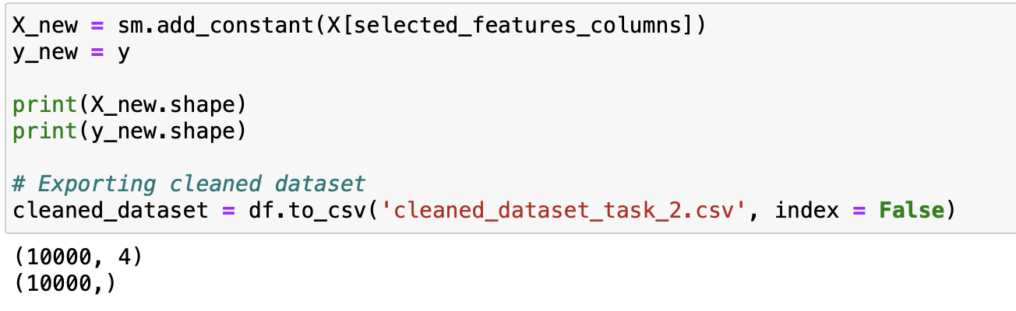
Figure 11: Cleaned Dataset Exported with New X and Y Variables for Splitting the Data

C4: Provide Copy of Cleaned Data Set (this is in assessment submission)

Part IV: Model Analysis

D1: Split Data into Training and Test Data Sets and Provide File(s) (this is in assessment submission)

D2: Describe Analysis Technique to Analyze Data – Include screenshots of intermediate calculations
Before running the algorithm, the dataset was first split into a training and testing subset. Getting training and test data for features and the dependent variable requires using train_test_split function. This was performed using SKLearn’s model_selection function. A test size of 20% was used. Moreover, the option stratify was used to not have any one variable overpower the others with stratify = y. The data was passed to X_test, X_train, y_test and y_train respectively. The model is trained on the training data set and evaluated on the testing data set. This approach is called hold-out validation (Bruce 2020). Splitting the train and test data into subsets help improve accuracy.
Once the data is split, then we build the model by instantiating and fitting the decision tree classifier towards the training data. Next, we identify values for parameters using hyperparameter tuning. Then, we instantiate the GridSearchCV() object. After this, we perform GridSearchCV and train the model. Once this is done, we check and print best parameters used from the model. Then, we calculate accuracy scores. The accuracy score describes the correct classifications over total samples (Elleh 2024). Following this, we calculate and print the mean squared error (MSE), root mean squared error (RMSE), and R-squared scores. Next, we perform predictions on the test data and print test accuracy scores. Finally, we determine the most predictive features according to Decision Tree Classifier.
Decision trees are non-parametric learning methods that build models in a tree structure (Elleh 2024). It breaks down a data set into smaller and smaller subsets while at the same time an associated decision tree is incrementally developed (Elleh 2024). The result is a tree with decision nodes and leaf nodes (Elleh 2024). A decision node has two or more branches (Elleh 2024). Leaf node represents a classification or decision (Elleh 2024). The topmost decision node in a tree corresponds to the best predictor called the root node (Elleh 2024). Decision trees can handle both categorical and numerical data (Elleh 2024).
Identifying hyperparameters is critical to avoid overfitting (Bruce 2020). For this reason, we start by defining the parameters for ‘min_samples_leaf’ and ‘max_depth’. Min_samples_leaf is especially important as this defines the minimum size for terminal nodes (leaves in the tree) (Bruce 2020). The default is 1 for classification and regression in Python (Bruce 2020). The reason the default values are not used in this analysis is because the defaults may lead to overfitting when applied to the decision tree if it contains noisy data (Bruce 2020). When you increase min_samples_leaf, the algorithm will fit smaller trees and is less likely to create spurious predictive rules (Bruce 2020). The parameter max_depth is the maximum depth of a leaf node to the root of the tree with a default value of three (Bruce 2020). This gives us another way to control overfitting: deep trees tend to be more complex and may overfit the data (Bruce 2020).
Cross-validation is used in this analysis to test the effects of setting different values for the hyperparameters (Bruce 2020). Cross-validation randomly splits up the data into K different groups, also called folds (Bruce 2020). For each fold, a model is trained on the data not in the fold and then evaluated on the data in the fold (Bruce 2020). This yields a measure of accuracy of the model on out-of-sample data (Bruce 2020). The best set of hyperparameters is the one given by the model with the lowest overall error as computed by averaging the errors from each of the folds (Bruce 2020).
To optimize hyperparameter tuning, the model was tuned with the AdaBoostClassifier. Boosting is a general technique to fit a sequence of models by giving more weight to the records with large residuals for each successive round (Bruce 2020). Boosting fits a series of models, in which each successive model seeks to minimize the error of the previous model (Bruce 2020). AdaBoost is an early version of boosting that reweights the data based on the residuals (Bruce 2020).

D3: Provide code used to perform classification analysis from part D2
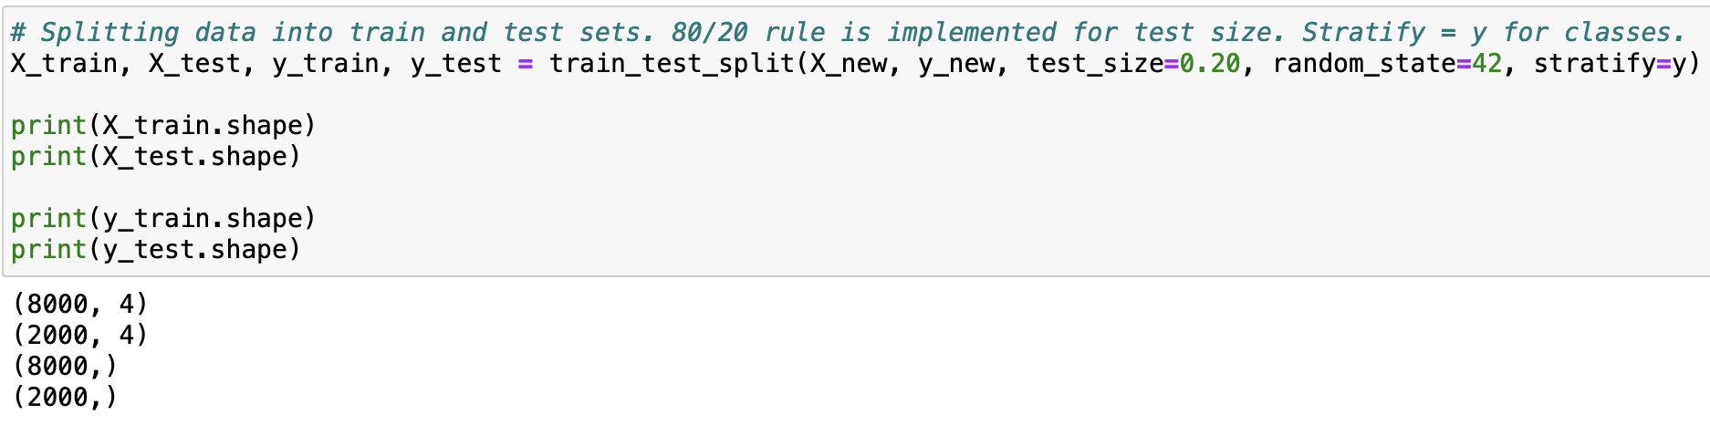
Figure 12: Splitting Train and Test Data
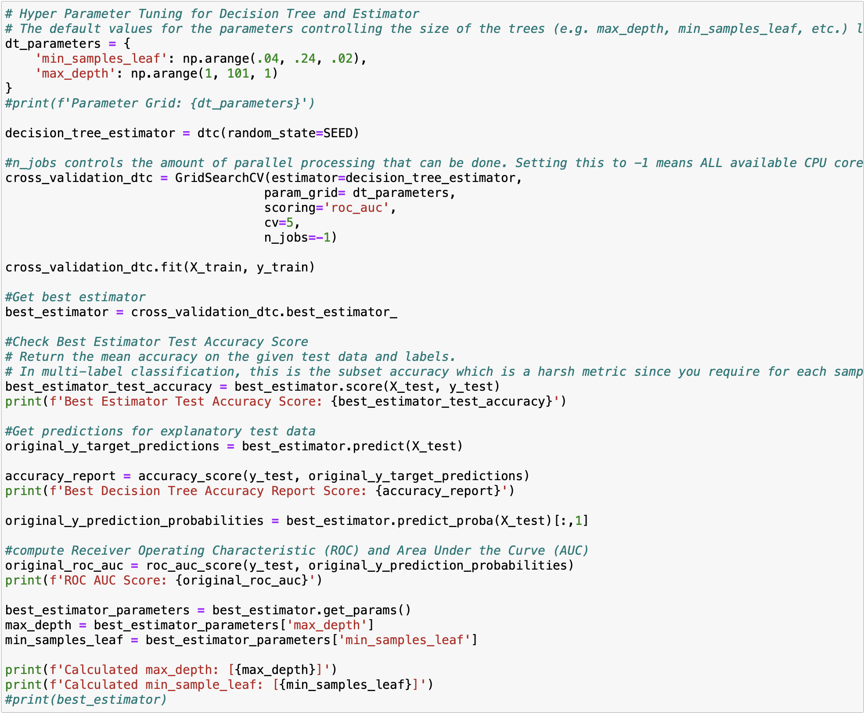
Figure 13: Hyper Parameter Tuning for Decision Tree. Cross Validation with GridSearchCV. Calculation of Estimator Accuracy Score, Decision Tree Accuracy Score, ROC AUC Score
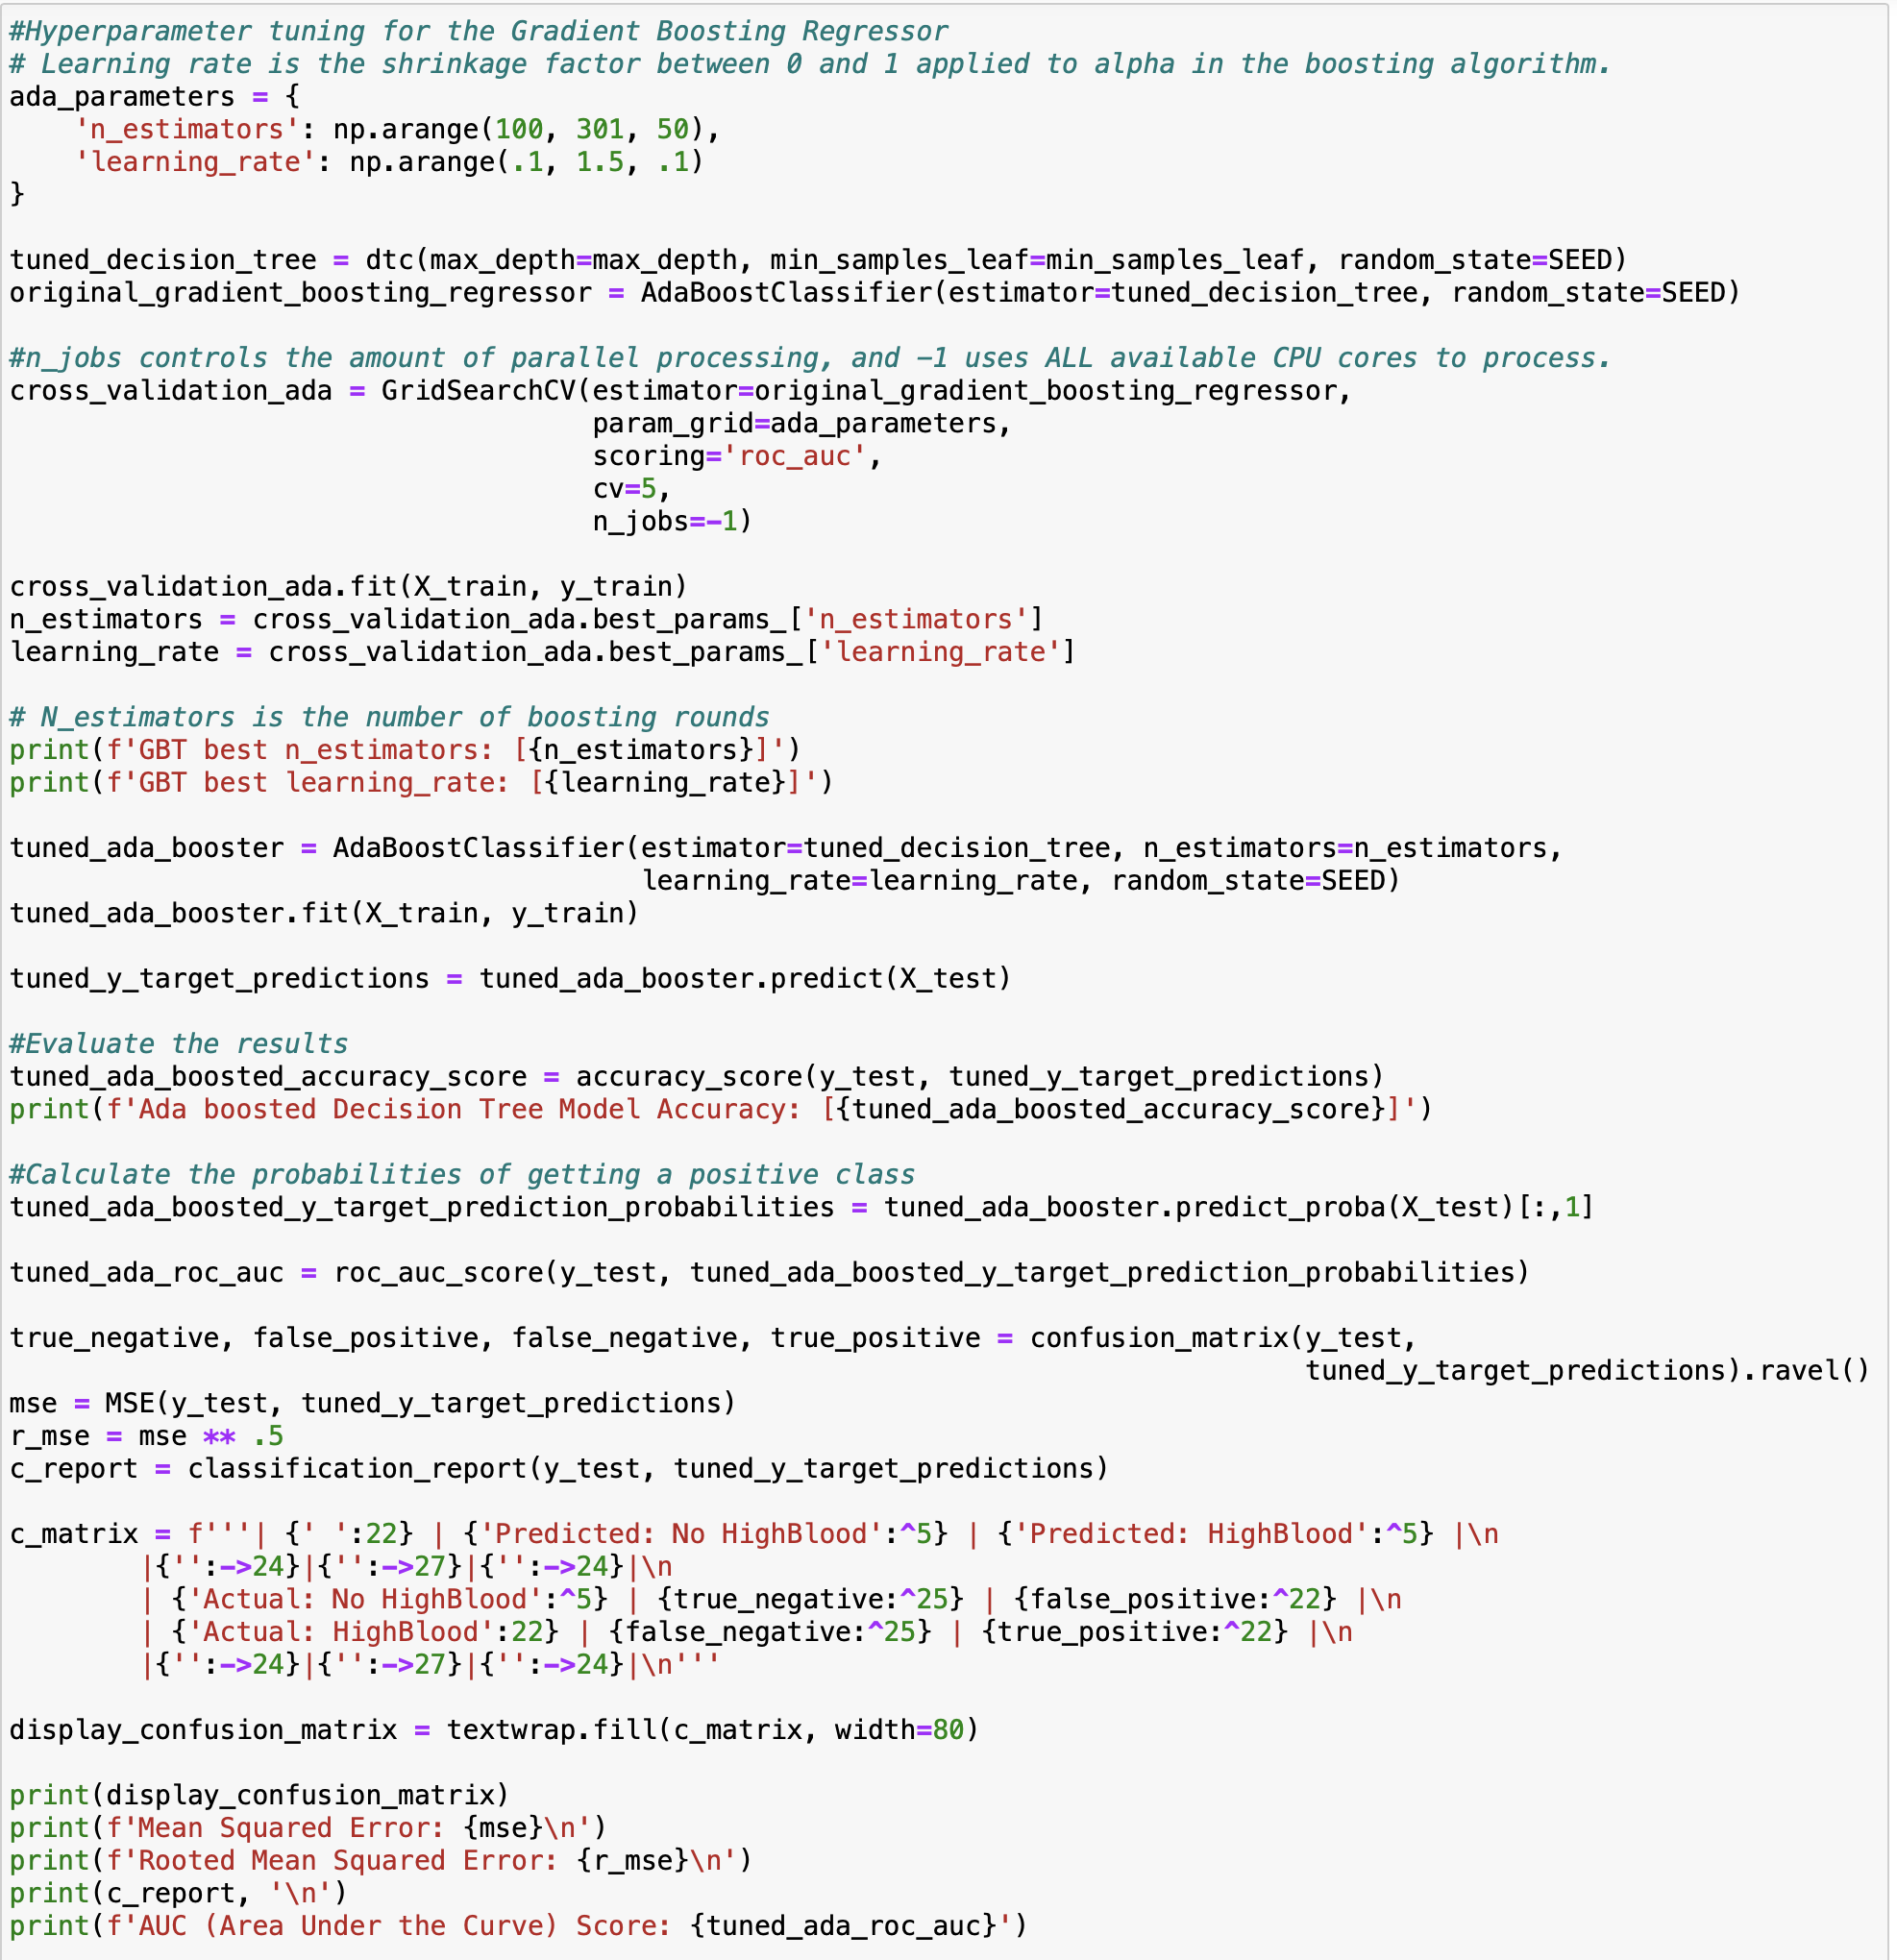
Figure 14: Hyper Parameter Tuning for Ada Boost Regressor. Cross Validation with GridSearchCV. Ada Booster Fit on Training Data. Calculation of Ada Boosted Decision Tree Model Accuracy. Probabilities of X Test, Confusion Matrix, MSE, RMSE, and AUC.
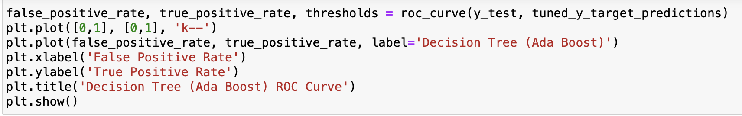
Figure 15: Code for Graph of Decision Tree ROC Curve
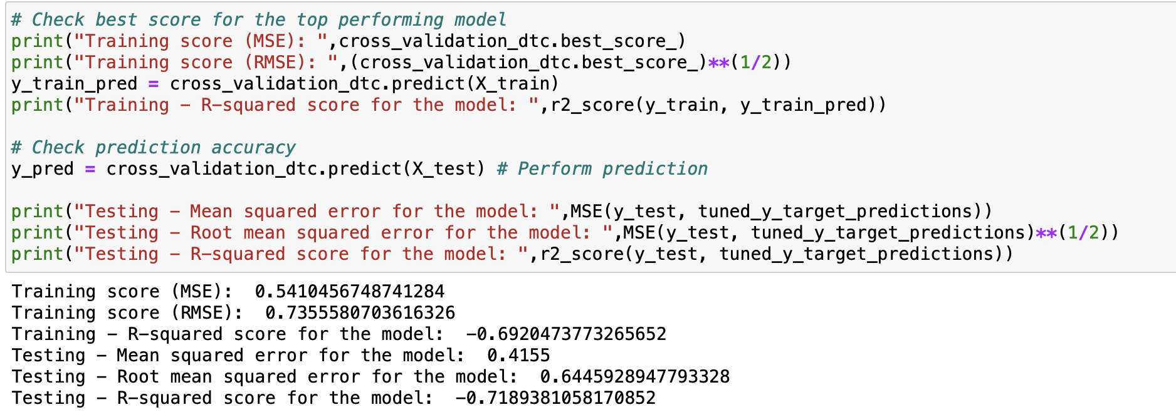
Figure 16: MSE, RMSE, and R2 of Training and Testing Data

Part V: Data Summary and Implications

E1: Explain Accuracy and Mean Squared Error (MSE) of Predictive Analysis
MSE is the sum of squares differences between predicted and actual values. It determines how good the estimate is based on the algorithm analysis (Elleh 2024). The predicted value is based on some equation and tells what you will expect as an average, but the result you get might differ from this prediction, which could result in a slight error from the estimated value (Elleh 2024). This difference is called MSE. The lower the value for MSE, the more accurately a model can predict values (Elleh 2024). RMSE and MSE can show if the degree of error is significant in the model. The model does a poor job predicting whether a patient will have high blood pressure or not. It makes correct predictions about 58% of the time. The MSE is 0.415 or about 42%, which indicates that the model’s predictions are not that close to the true outcomes.

E2: Discuss Results and Implications of Decision Trees
For our model, the accuracy score was 58% and the MSE was 0.4155. The accuracy score calculates how well, in percentage, the model classified the observations (Zach, 2021). In this case, the model correctly classified the observations ~58% of the time. On the other hand, the MSE, which is the average squared error between the actual values and the predicted value, was ~42%. The model’s Mean Squared Error (MSE) is 0.4155 (42%) suggesting that the model’s predictions are not that close to the true outcomes. A high MSE indicates that the model is not reliable and that its predictions cannot be trusted for decision-making purposes.
The point of the ROC curve is to see how far away from the diagonal line we can get in the positive direction. This is because the diagonal line represents the 50% correct classification rate, where complete randomness would hover around this line. If the classification line falls below the diagonal line, it’s a poor model, and if it goes above the diagonal line, it’s a better model. With an AUC of 0.533, this model is identical with the diagonal line, which means it’s a poor predictive model.

E3: Discuss one limitation of your data analysis
A limitation of the Decision Tree Classifier is noisy data. These can drag attention to instances that are wrongly predicted causing over-fitting. To help mitigate the issues brought on by static noise, we used SelectKBest during data cleaning to reduce the number of features used in the final model. We also deployed AdaBoost. This ensemble learning algorithm allows us to change the weights of the weakly predicted items to help correct the branch and leaf generation for the decision tree and increases its accuracy.

E4: Recommend a course of action for the real-world organization situation from part A1 based on your results and implications discussed in part E2
Based on this analysis report and the model’s accuracy score along with the MSE, the hospital can’t use this decision tree model to predict patients who are hypertensive. Based on exploratory data analysis and SelectKBest, patients who were Overweight, Married, and charged more were more likely to be hypertensive since these variables were statistically significant. To achieve better results, a bigger dataset comprising of more explanatory variables could help the results – more data means a bigger training set could be used so the model can have better predictive power. Moreover, there are other clinical parameters that can help in predicting hypertensive status – kidney disease (or lack thereof), activity level and other metabolic parameters can provide better real-world value rather than some of the variables shown in the dataset. Thirdly, varying stages of hypertensive status exist; the model cannot discriminate which stage a patient can potentially be in and is something that would have to be verified by a human clinician (American Heart Association, 2023). Given the statistical significance of the Overweight and Married variables, it is possible that the hospital could help patients with their diets by recommending them to personal trainers, dieticians, or providing insights on how to improve their nutritional habits. For people who are married, providing recommendations to marriage counselors or therapists could help improve their situation.

References (No third-party code references used)
Dr. Festus Elleh. (November 2024). D209 Webinars with Dr. Festus Elleh
Jo Hardin, Jason Vestuto, Nele Verbiest, Maggie Matsui, Richie Cotton, Maarten Van den Broeck. D209 – Data Mining. https://app.datacamp.com/learn/custom-tracks/custom-d209-data-mining.
Zach. (2021, September). Statology. Retrieved November 2024, from F1 Score vs. Accuracy: Which Should You Use?: https://www.statology.org/f1-score-vs-accuracy/
Stojilikovic, Mirko (July 15th, 2024). Split Your Dataset with scikit-learn’s train_test_split(). https://realpython.com/train-test-split-python-data/.
Bruce, Peter, et al. (April 10, 2020). Practical Statistics for Data Scientists: 50+ Essential Concepts Using R and Python. O’Reilly Media; 2nd edition
Raj, Piyush. Pandas – Count of Unique Values in Each Column. https://datascienceparichay.com/article/pandas-count-of-unique-values-in-each-column/.
Moffitt, Chris. (February 6th, 2017). Guide to Encoding Categorical Values in Python. https://pbpython.com/categorical-encoding.html.
American Heart Association. (2024, May 17). Understanding Blood Pressure Readings. Retrieved from High Blood Pressure: https://www.heart.org/en/health-topics/high-blood-pressure/understanding-blood-pressure-readings

Table of Figures
Figure 1: Importing Libraries and Loading Data 10
Figure 2: Renaming Columns 11
Figure 3: Dropping Irrelevant Variables 12
Figure 4: Checking for Null Values 14
Figure 5: Checking for Duplicates 14
Figure 6: Mapping Binary Categoricals 14
Figure 7: Get_dummies to Re-express Categorical Variables 14
Figure 8: Ordinal Encoding for Complication_risk 15
Figure 9: Summary Stats of Cleaned Data Frame 15
Figure 10: Feature Selection with SelectKBest 15
Figure 11: Cleaned Dataset Exported with New X and Y Variables for Splitting the Data 16
Figure 12: Splitting Train and Test Data 18
Figure 13: Hyper Parameter Tuning for Decision Tree. Cross Validation with GridSearchCV. Calculation of Estimator Accuracy Score, Decision Tree Accuracy Score, ROC AUC Score 19
Figure 14: Hyper Parameter Tuning for Ada Boost Regressor. Cross Validation with GridSearchCV. Ada Booster Fit on Training Data. Calculation of Ada Boosted Decision Tree Model Accuracy. Probabilities of X Test, Confusion Matrix, MSE, RMSE, and AUC. 20
Figure 15: Code for Graph of Decision Tree ROC Curve 20
Figure 16: MSE, RMSE, and R2 of Training and Testing Data 21

